**Home Made Pickles & Snacks**

**Project Description:**

**Homemade Pickles & Snacks — Taste the Best** is an innovative, cloud-powered culinary platform dedicated to delivering handcrafted, preservative-free pickles and snacks rooted in tradition. This project blends the authenticity of time-honored recipes with modern technology to bring fresh, flavorful, and healthy food options directly to consumers.

Harnessing the power of the Flask framework for a streamlined backend and AWS EC2 for reliable, scalable hosting, the platform ensures smooth navigation, secure ordering, and flexible subscription models. Real-time inventory and personalized user interactions are driven by DynamoDB, enabling an efficient, responsive experience.

Beyond technology, the initiative is deeply committed to sustainability. Ingredients are sourced from local farmers, promoting community agriculture and reducing food miles. Eco-conscious packaging further supports the platform’s mission of environmental responsibility.

**Homemade Pickles & Snacks — Taste the Best** redefines how tradition meets innovation—**preserving culinary heritage, one jar at a time.**

**Scenarios:**

**Scenario 1: Scalable Order Management for High Demand**

A robust cloud infrastructure supports smooth order handling during traffic surges. During major sales or festival seasons, the system can accommodate large numbers of concurrent users without slowing down. The backend handles simultaneous order placements, session tracking, and live inventory changes efficiently. With dynamic resource allocation, it ensures optimal performance and fast checkouts, reducing cart abandonment and ensuring customer satisfaction.

**Scenario 2: Real-Time Inventory Tracking and Updates**

Each order triggers instant inventory adjustments and transaction recording. For instance, once a purchase is made, stock levels are automatically updated and the order is logged for processing. Staff can monitor inventory trends via updated dashboards, enabling fast decisions on restocking. This automation reduces manual errors, prevents product shortages, and ensures customers always receive accurate availability information.

**Scenario 3: Personalized User Experience and Recommendations**

User activity is analyzed to deliver customized shopping suggestions. For example, based on browsing patterns and order history, the system displays relevant products to returning users. These recommendations are refreshed in real-time, enhancing engagement and increasing conversions. Even under high user loads, the platform maintains responsiveness and a user-centric interface, promoting a smooth and enjoyable buying experience.

AWS ARCHITECTURE

This AWS-based architecture powers a scalable and secure web application using Amazon EC2 for hosting the backend, with a lightweight framework like Flask handling core logic. Application data is stored in Amazon DynamoDB, ensuring fast, reliable access, while user access is managed through AWS IAM for secure authentication and control. Real-time alerts and system notifications are enabled via Amazon SNS, enhancing communication and user engagement

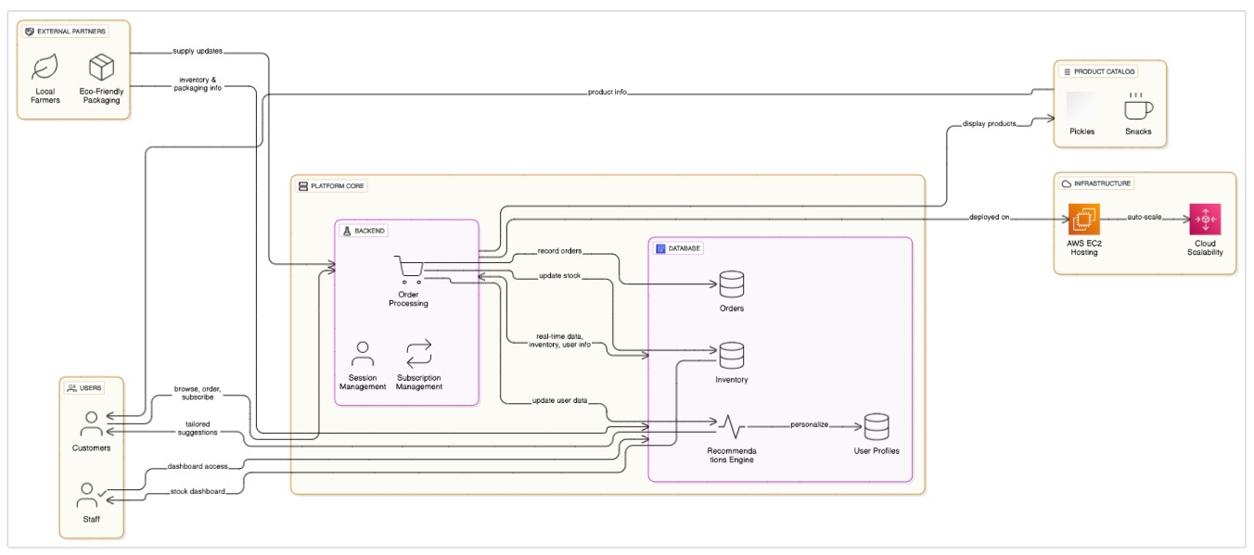

Entity Relationship (ER)Diagram:

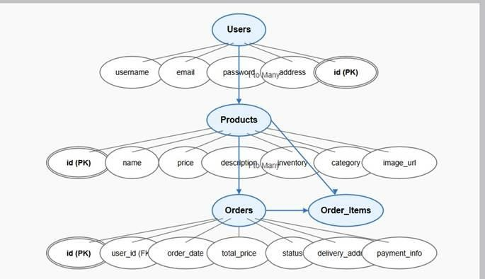

**Pre-requisites:**

* AWS Account Setup: <https://docs.aws.amazon.com/accounts/latest/reference/getting-started.html>
* AWS IAM (Identity and Access Management): <https://docs.aws.amazon.com/IAM/latest/UserGuide/introduction.html>
* AWS EC2 (Elastic Compute Cloud):

<https://docs.aws.amazon.com/AWSEC2/latest/UserGuide/concepts.html>

* AWS DynamoDB:

[https://docs.aws.amazon.com/amazondynamodb/Introduction.html](https://docs.aws.amazon.com/amazondynamodb/latest/developerguide/Introduction.html)

* Git Documentation:

<https://git-scm.com/doc>

* VS Code Installation: (download the VS Code using the below link or you can get that in Microsoft store)

<https://code.visualstudio.com/download>

**Project WorkFlow:**

**Milestone 1. Backend Development and Application Setup**

* Develop the Backend Using Flask.
* Integrate AWS Services Using boto3.

**Milestone 2. AWS Account Setup and Login** • Set up an AWS account if not already done.

* Log in to the AWS Management Console **Milestone 3. DynamoDB Database Creation and Setup**
* Create a DynamoDB Table.
* Configure Attributes for User Data and Book Requests.

**Milestone 4. SNS Notification Setup**

* Create SNS topics for book request notifications.
* Subscribe users and library staff to SNS email notifications.

**Milestone 5. IAM Role Setup**

* Create IAM Role
* Attach Policies

**Milestone 6. EC2 Instance Setup**

* Launch an EC2 instance to host the Flask application.
* Configure security groups for HTTP, and SSH access.

**Milestone 7. Deployment on EC2**

* Upload Flask Files
* Run the Flask App

**Milestone 8. Testing and Deployment**

* Conduct functional testing to verify user signup, login, buy/sell stocks and notifications.

# Milestone 1: Backend Development and Application SetUp

● **Activity 1.1:** Develop the Backend Using Flask

1. File Explorer Structure

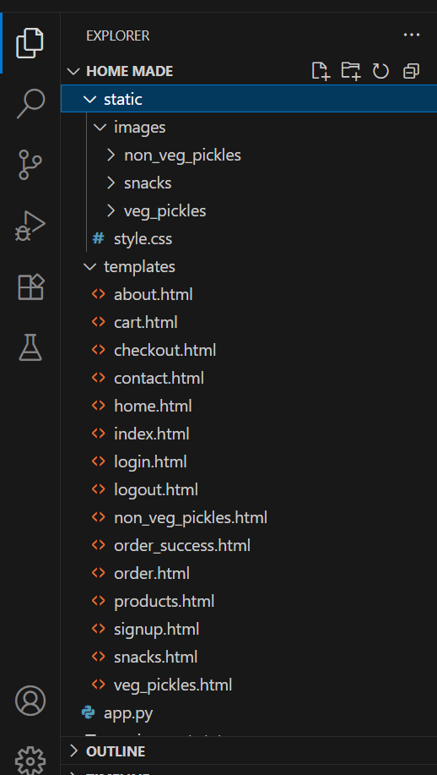

**Description:** Backend Development and Application Setup focuses on establishing the core structure of the application. This includes configuring the backend framework, setting up routing, and integrating database connectivity. It lays the groundwork for handling user interactions, data management, and secure access.

**Important Instructions:**

* + Start by creating the necessary HTML pages and Flask routes (app.py) to build the core functionality of your application.

* + During the initial development phase, store and retrieve data using Python dictionaries or lists locally. This will allow you to design, test, and validate your application logic without external database dependencies

**Description of the code :**

? Flask App Initialization

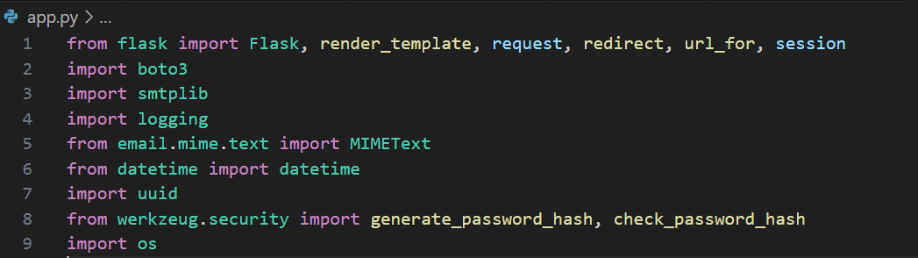

* + Use boto3 to connect to DynamoDB for handling user registration, Order details database operations and also mention region_name where Dynamodb Tables are created.

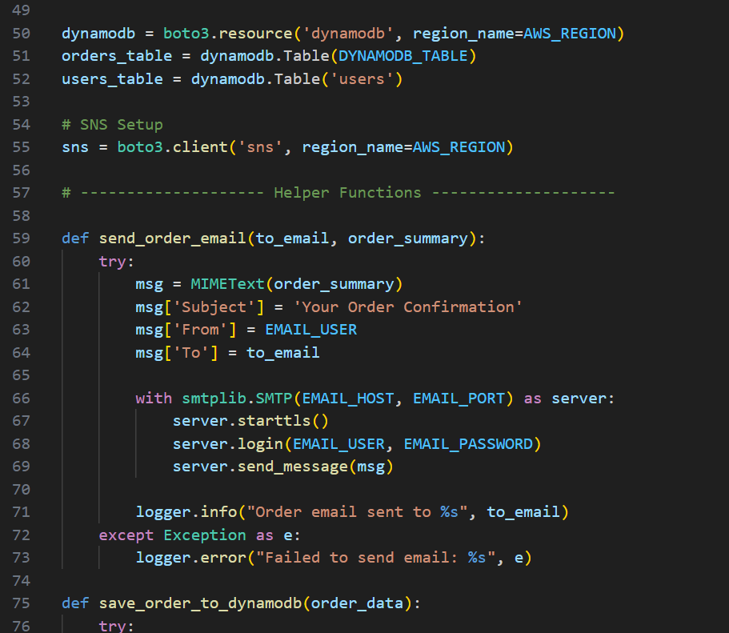

* + Routes for Web Pages

Login Route (GET/POST):Verifies user credentials, increments login count, and redirects to the dashboard on success.

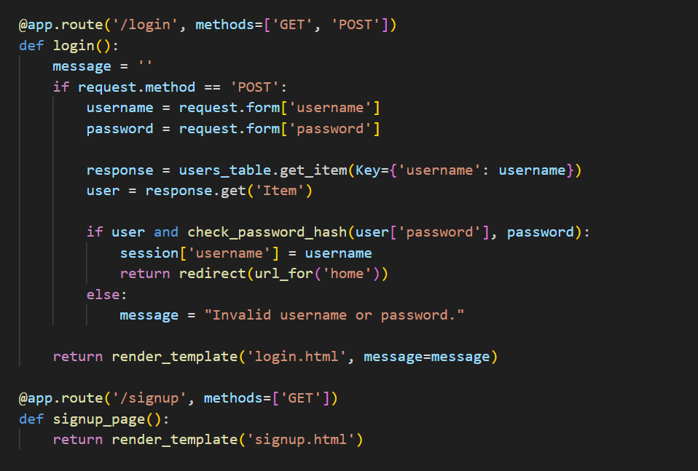

SignUp route: Collecting registration data, hashes the password, and stores user details in the details in the database.

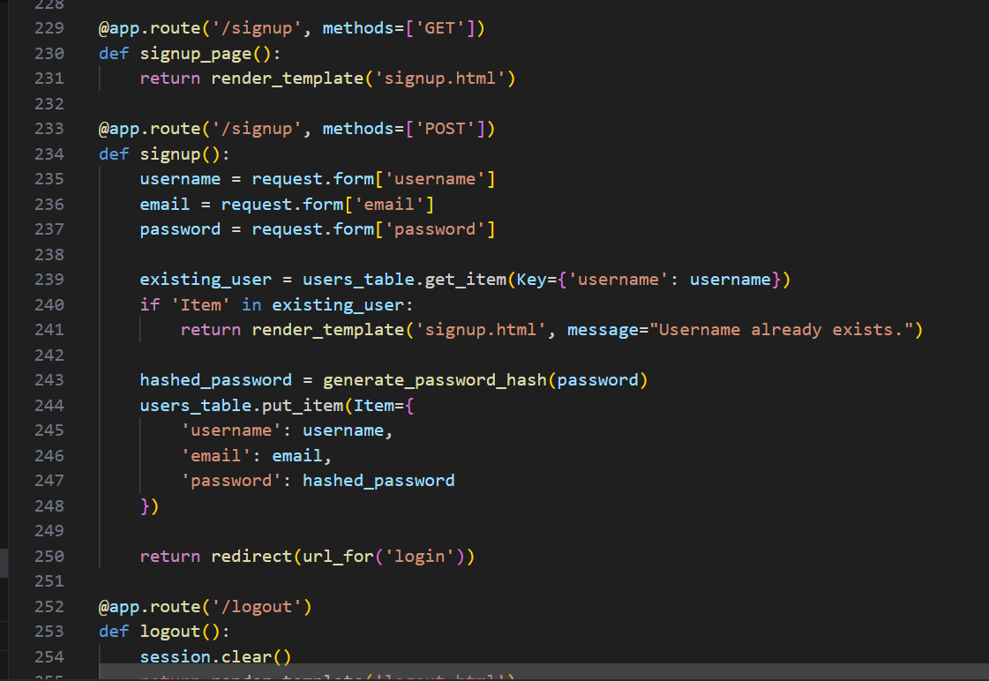

Home Route: Home page contains the routing for different categories which are Veg_pickles,Non_Veg_pickles,Snacks.

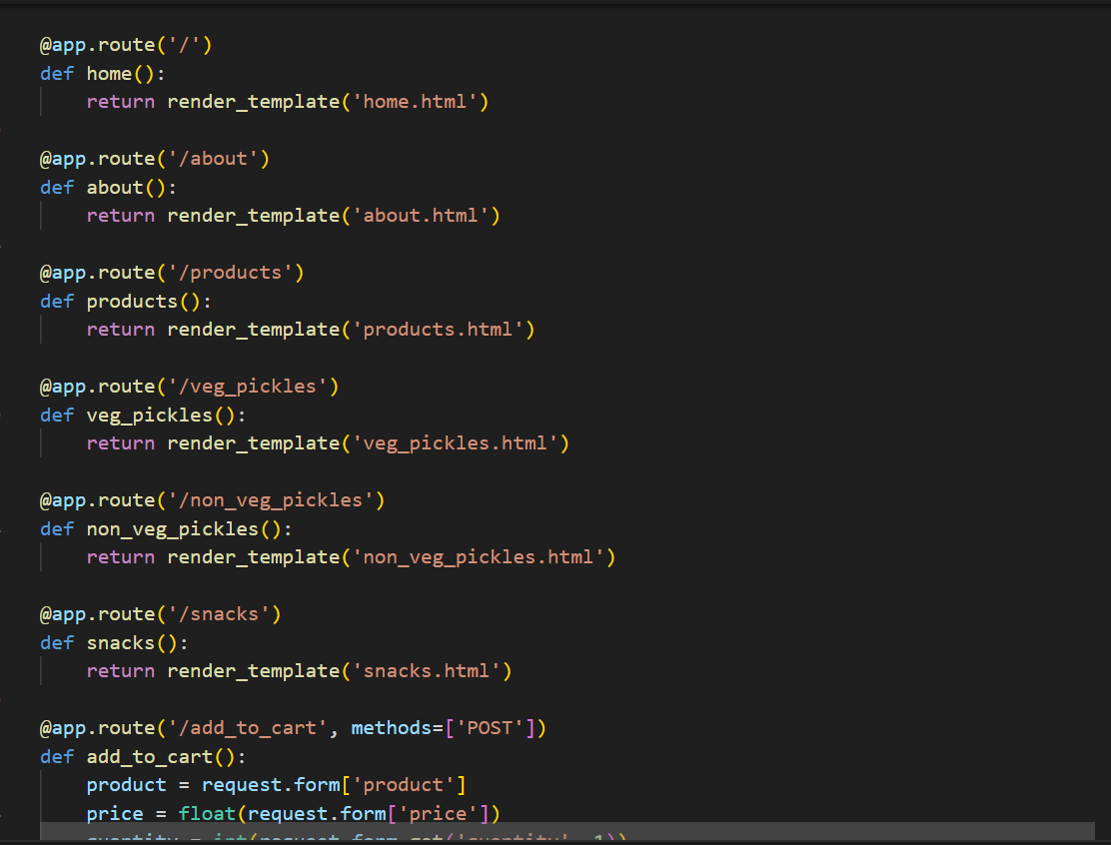

CheckOut

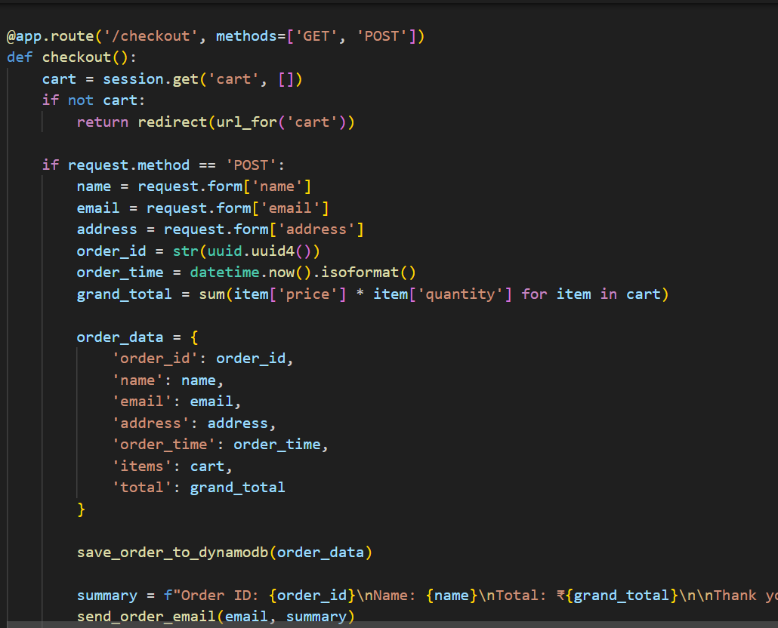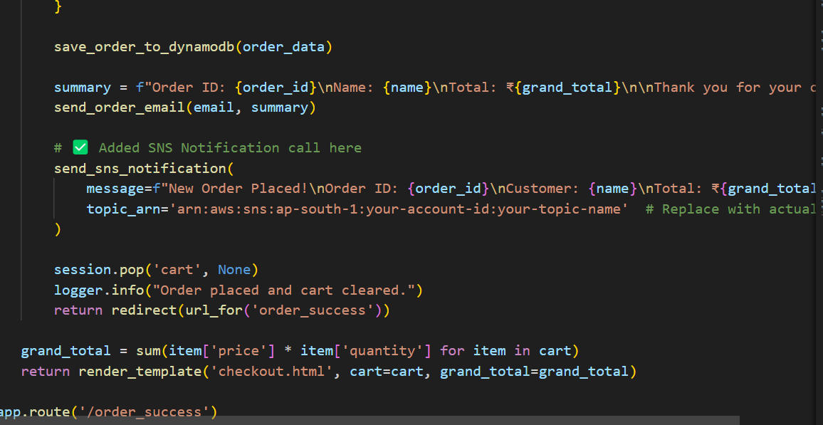

**Milestone 2: AWS Account Setup and Login.**

o **Activity 2.1:** Set up an AWS account if not already done.

* Sign up for an AWS account and configure billing settings.

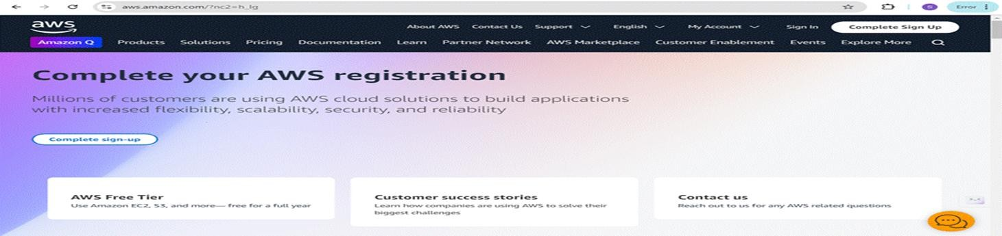

* Click on the "Create an AWS Account" button.
* Follow the prompts to enter your email address and choose a password.
* Provide the required account information, including your name, address, and phone number.
* Enter your payment information. (Note: While AWS offers a free tier, a credit card or debit card is required for verification.)
* Complete the identity verification process.
* Choose a support plan (the basic plan is free and sufficient for starting).
* Once verified, you can sign in to your new AWS accounts**.**

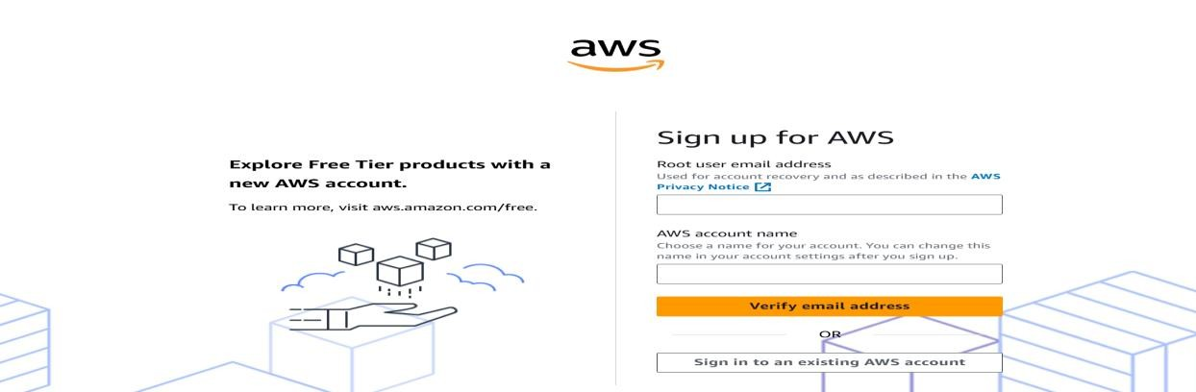

* **Activity2.2 :** Log in to the AWS Management Consoleo After setting up your account, log in to the [AWS Management Console**.**](https://aws.amazon.com/console/)

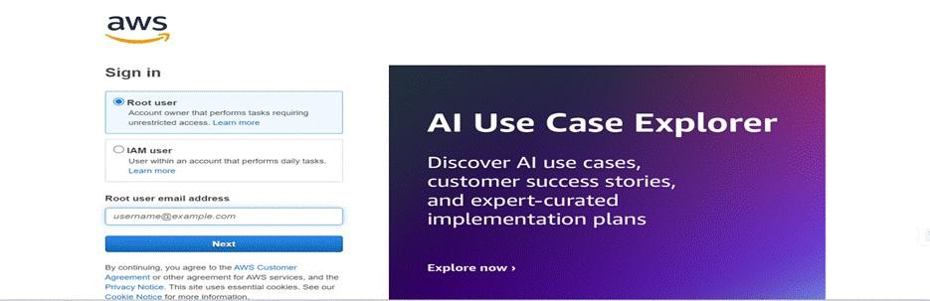

# Milestone 3: DynamoDB Database Creation and Setup

* **Activity 3.1:**Navigate to the DynamoDBo In the AWS Console, navigate to DynamoDB and click on create tables**.**

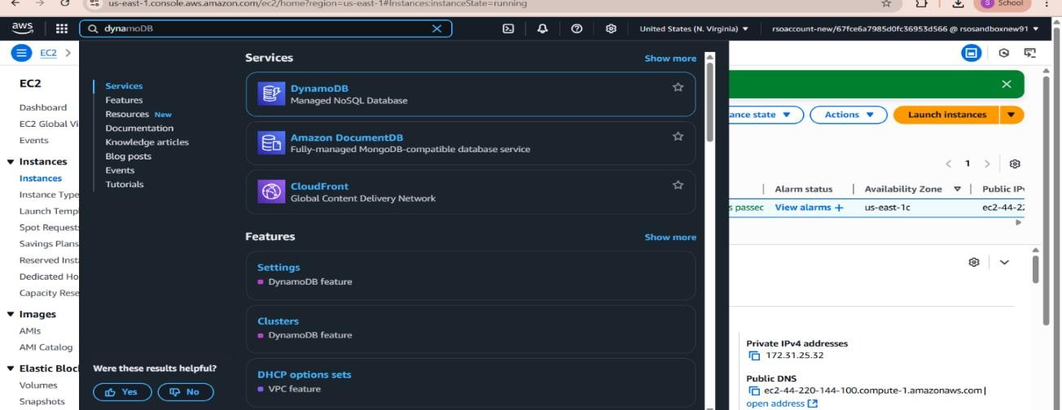

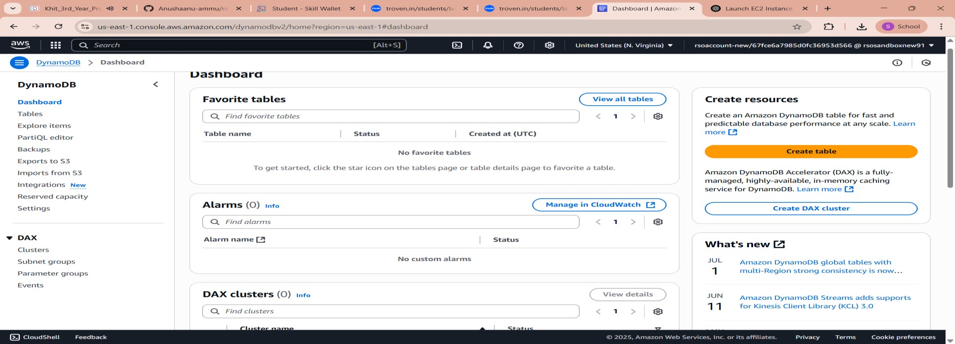

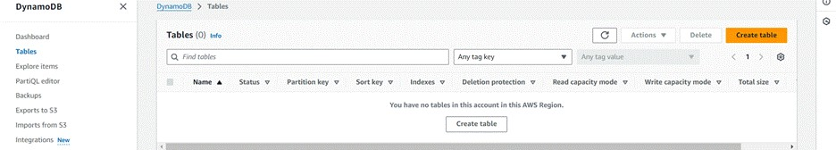

**Activity 3.2**: Create a DynamoDB table for storing registration details and book requests.

* Create Users table with partition key “Email ” with type String and click on create tables.

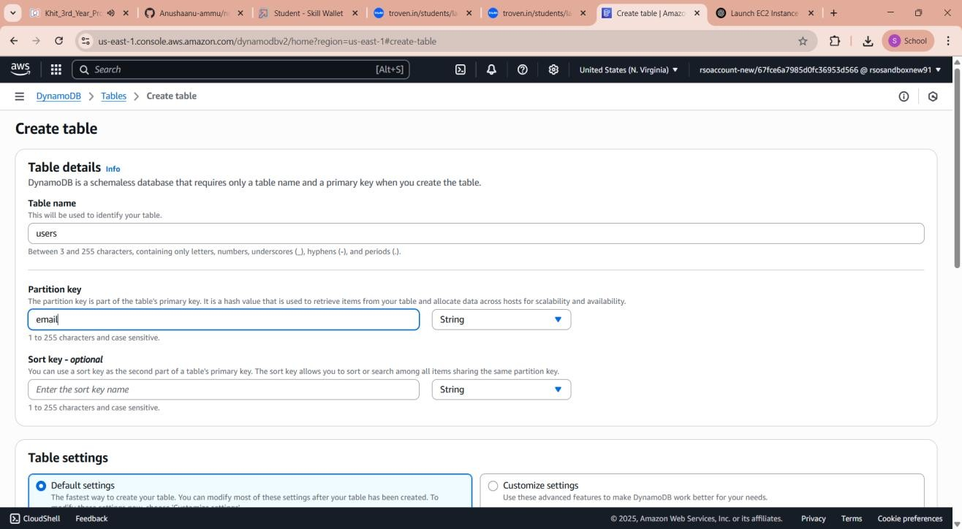

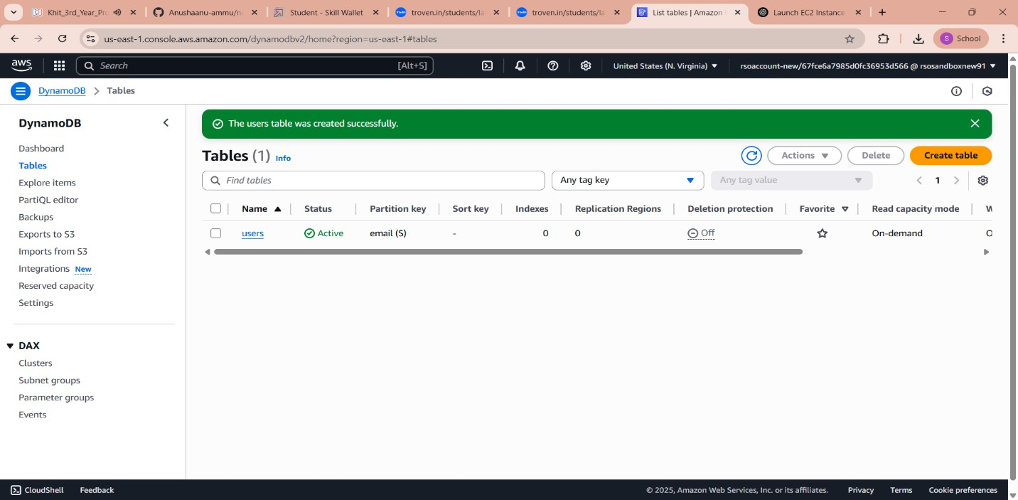

* Follow the same steps to create an Orders table with Order_id as the primary key to store Order details.

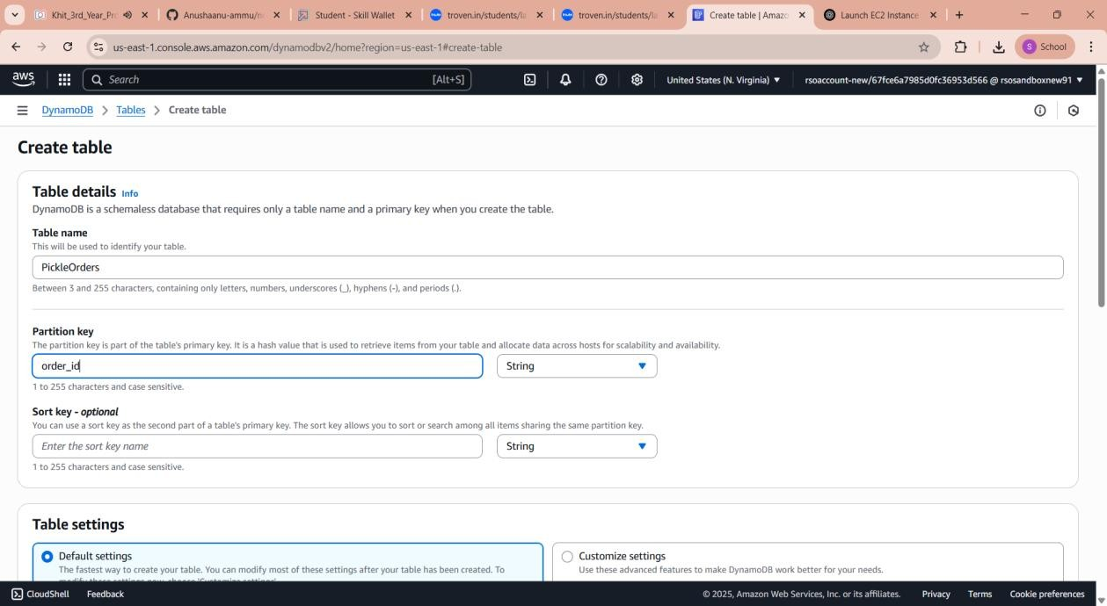

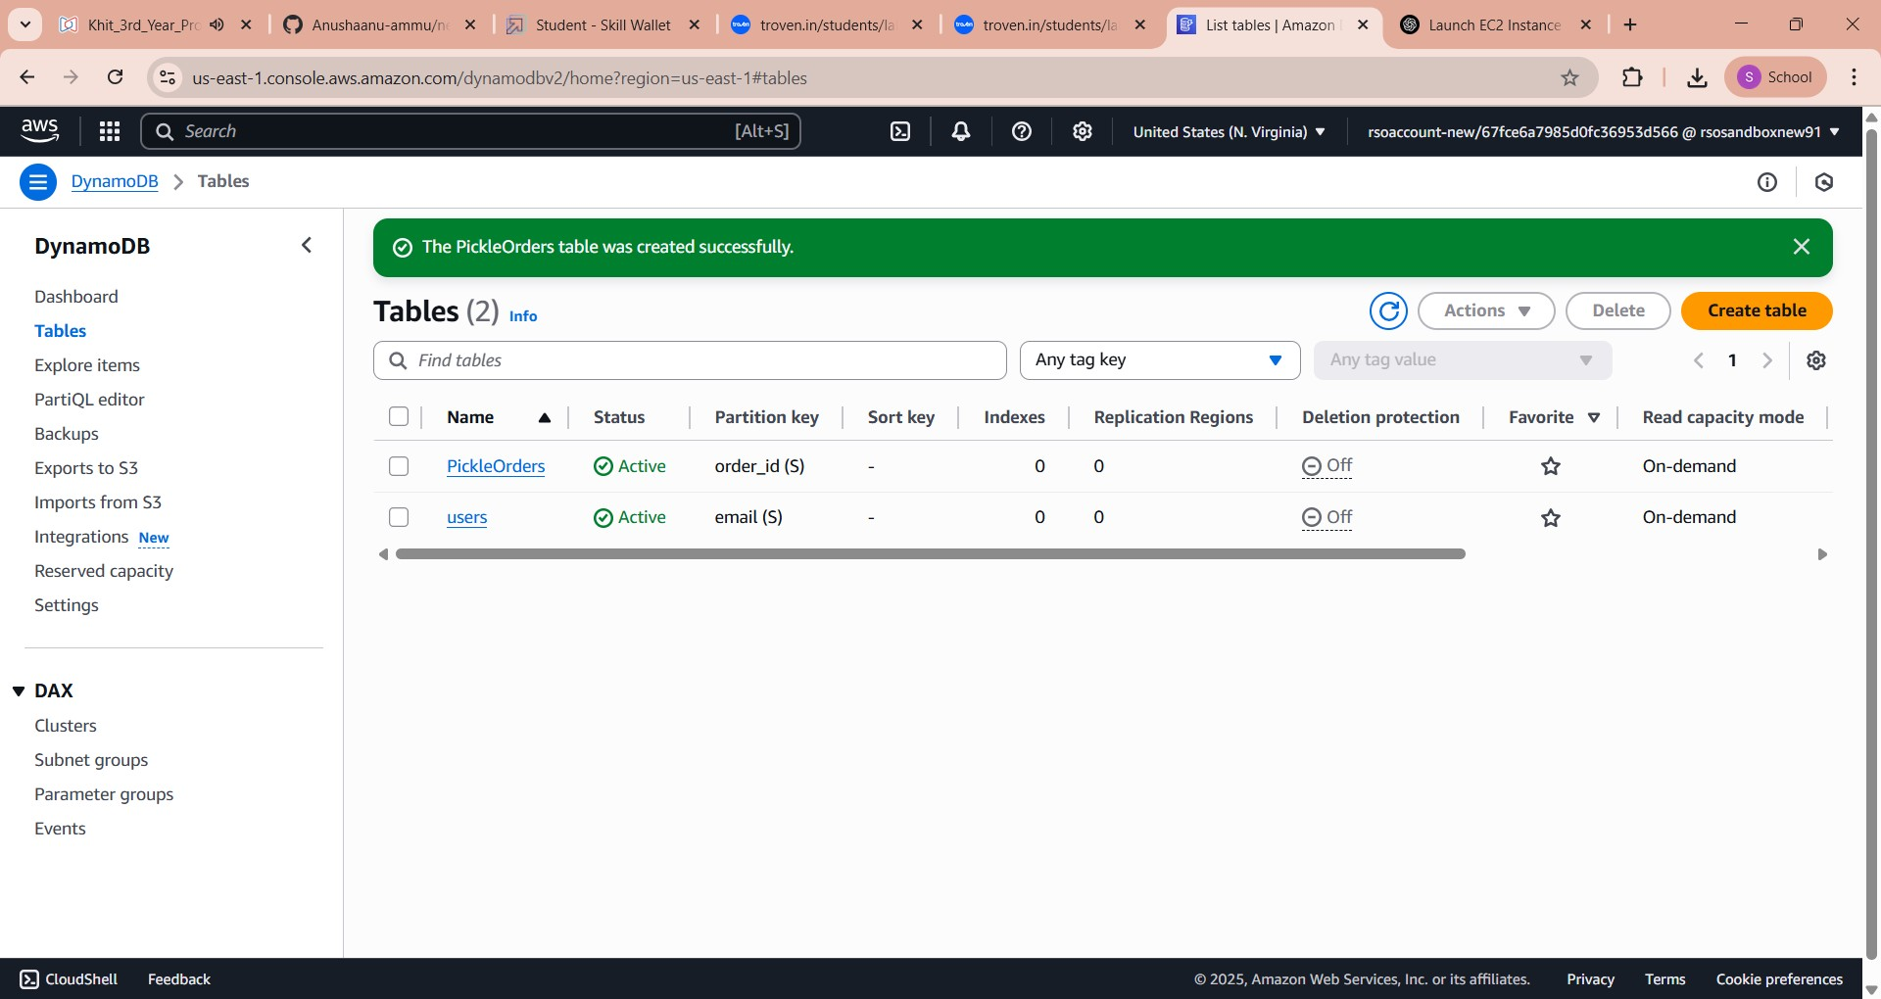

# Milestone 4. SNS Notification Setup

* **Activiy4.1:** Create SNS topics for book request notifications**.**

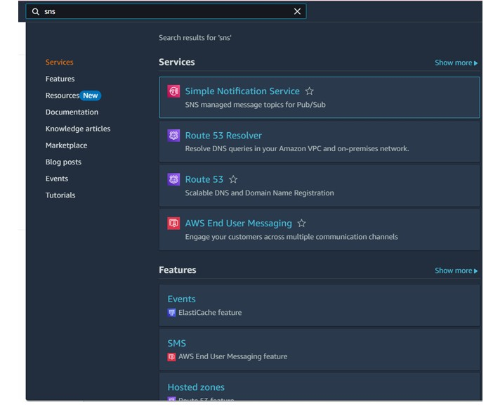

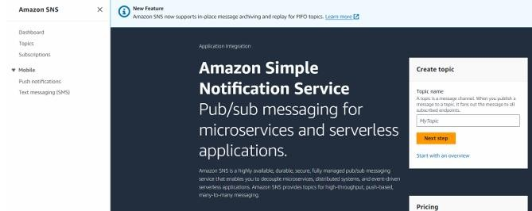

* Click on Create Topic and choose a name for the topic

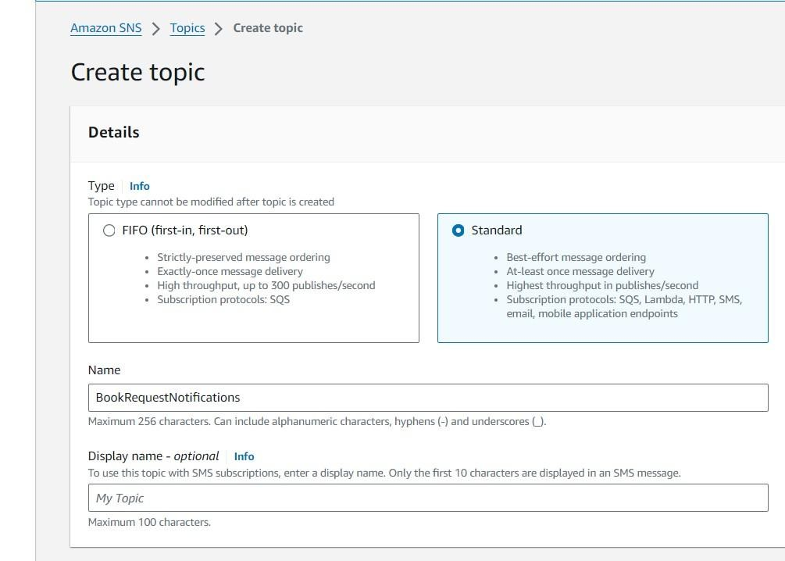

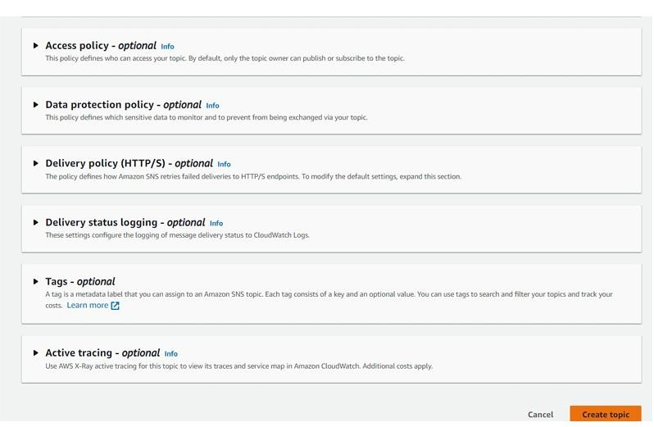

* Configure the SNS topic and note down the Topic ARN

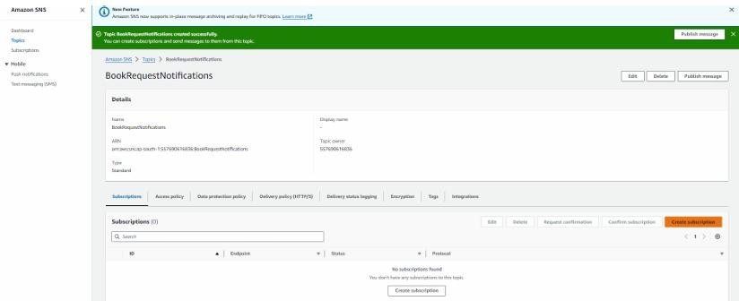

○ Subscribe users and library staff to SNS email notifications.

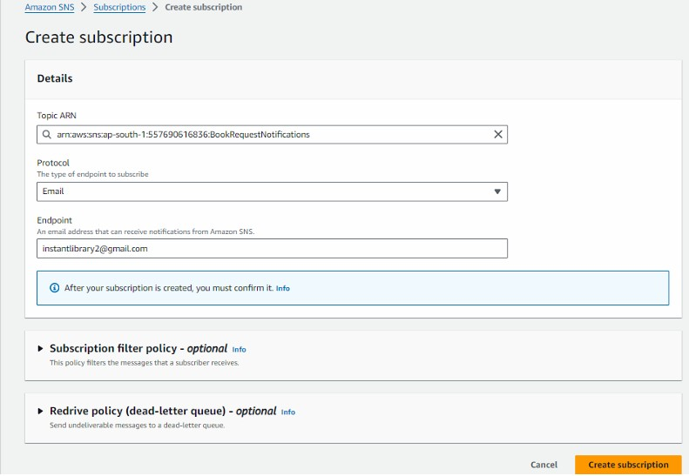

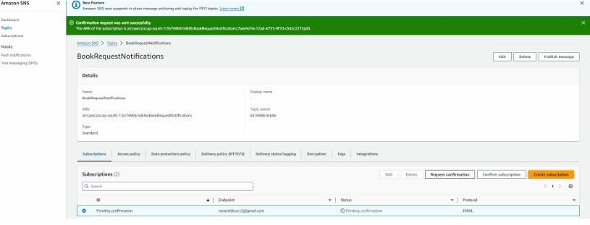

* After Comfirmation of Subscription going to Mail for comfirm Mail .

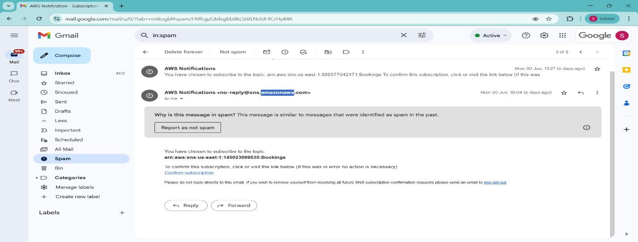

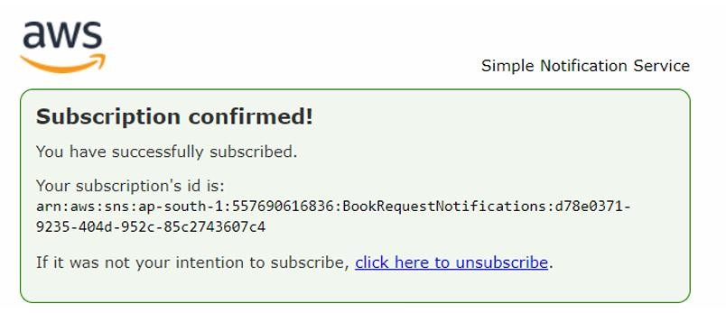

**Milestone 5 : IAM Role Setup.**

* **Activity 5.1 :** In the AWS Console, go to IAM and create a new IAM Role for EC2 to interact with DynamoDB .

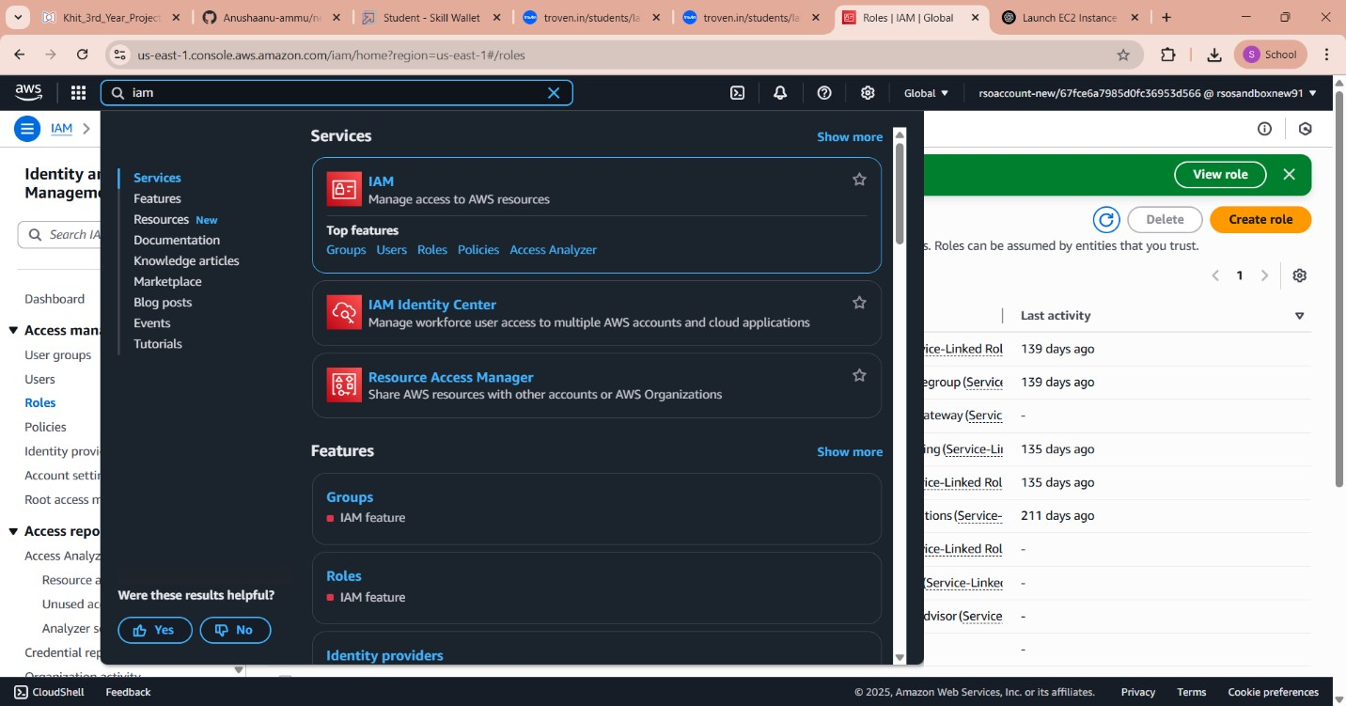

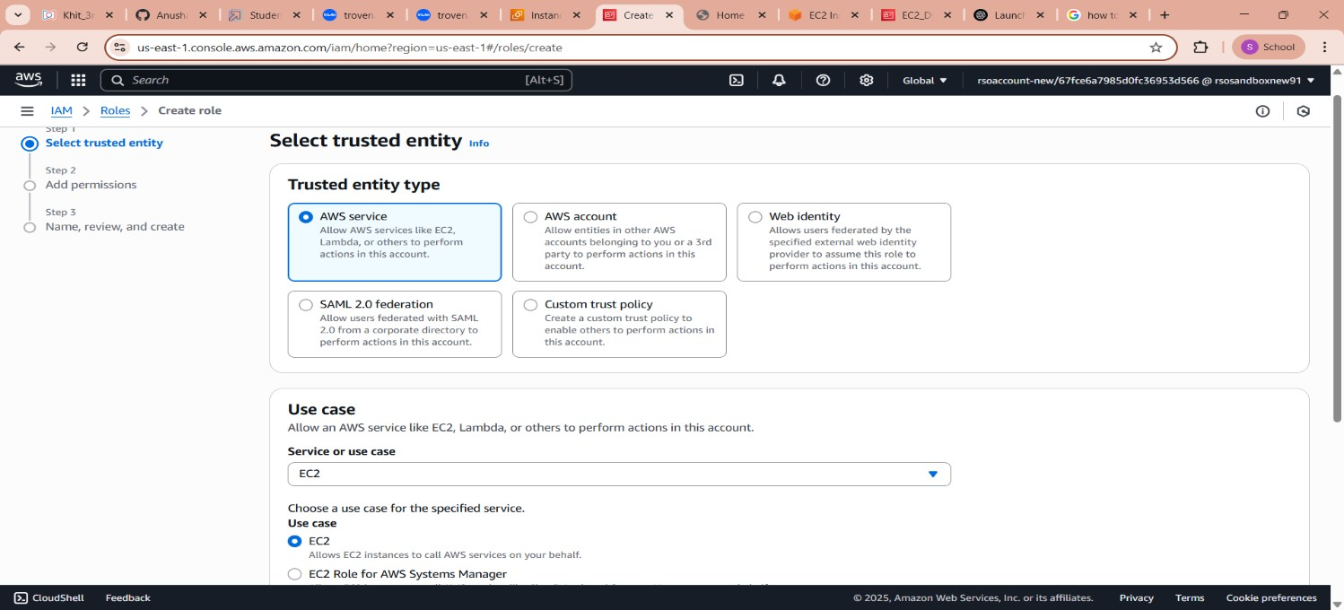

* **Activity 5.2 : Attach Policies**
* AmazonDynamoDBFullAccess: Allows EC2 to perform read/write operations on DynamoDB.
* AmazonSNSFullAccess: Grants EC2 the ability to send notifications via SNS.

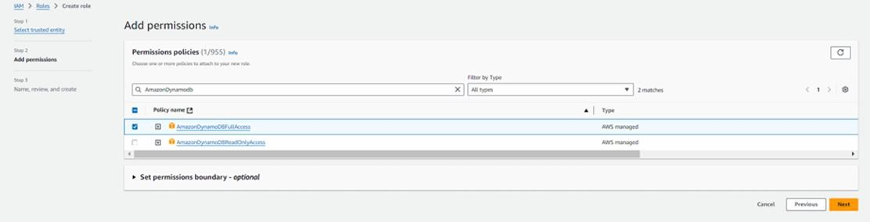

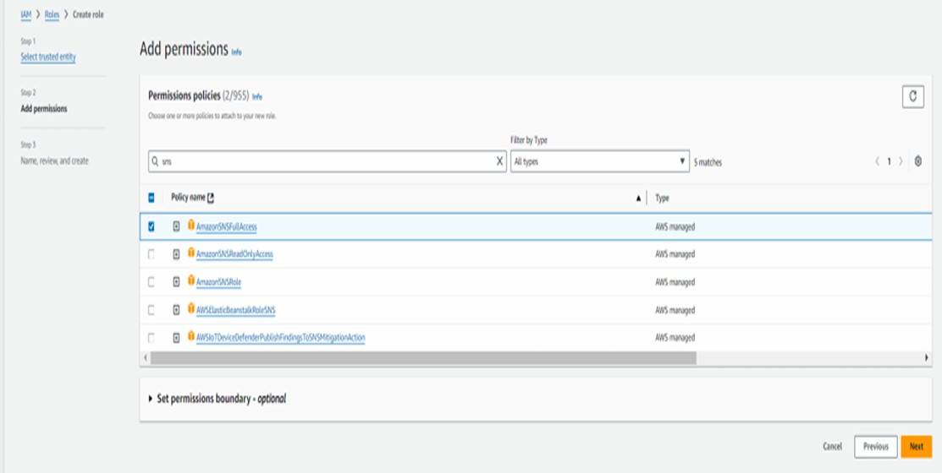

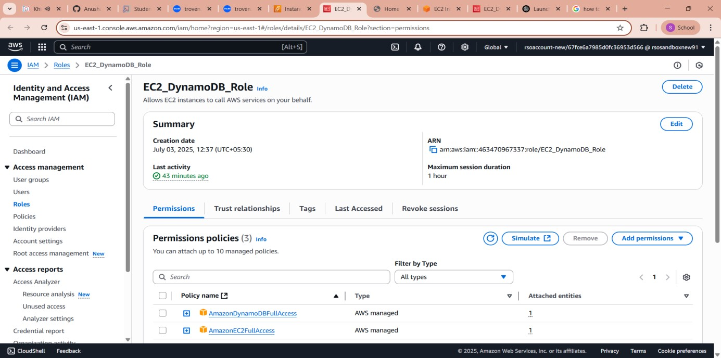

# o Milestone 6. EC2 Instance Setup

**Note: Load your Flask app and Html files into GitHub repository .**

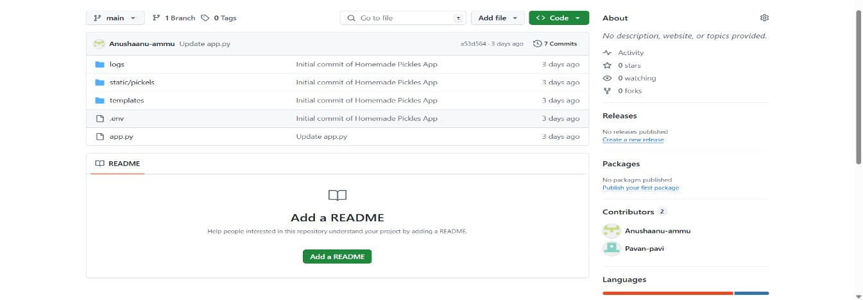

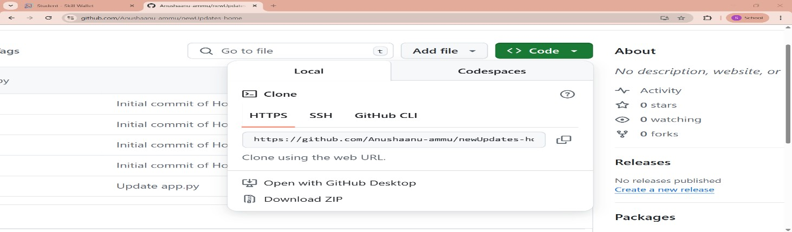

**Activity 6.1:** Launch an EC2 instance to host the Flask application.

o In the AWS Console, navigate to EC2 and launch a new instance.

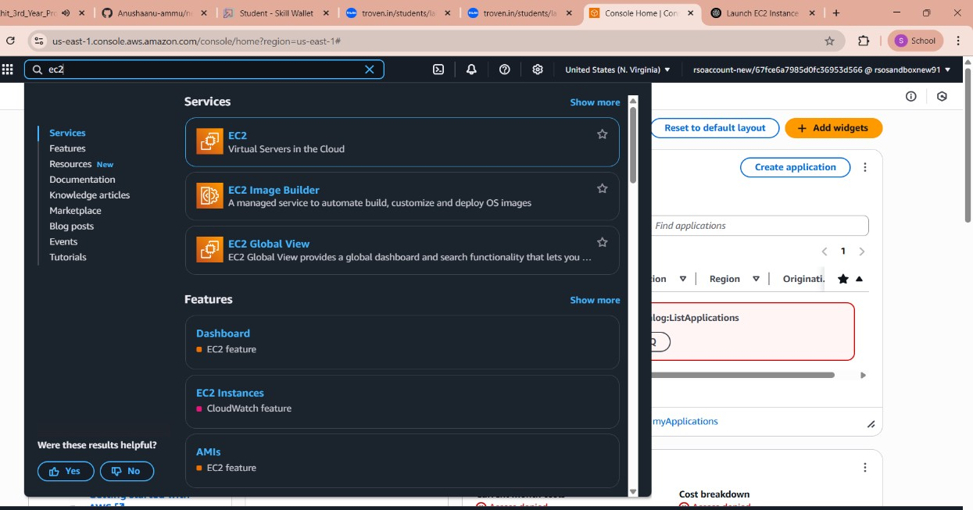

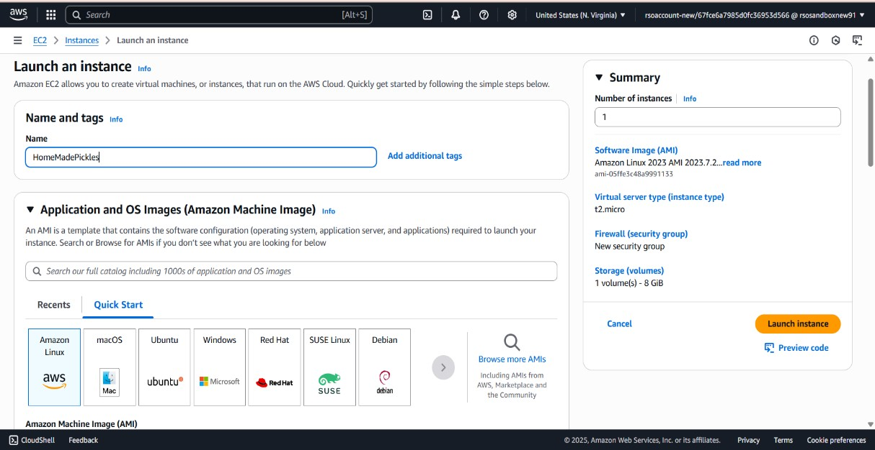

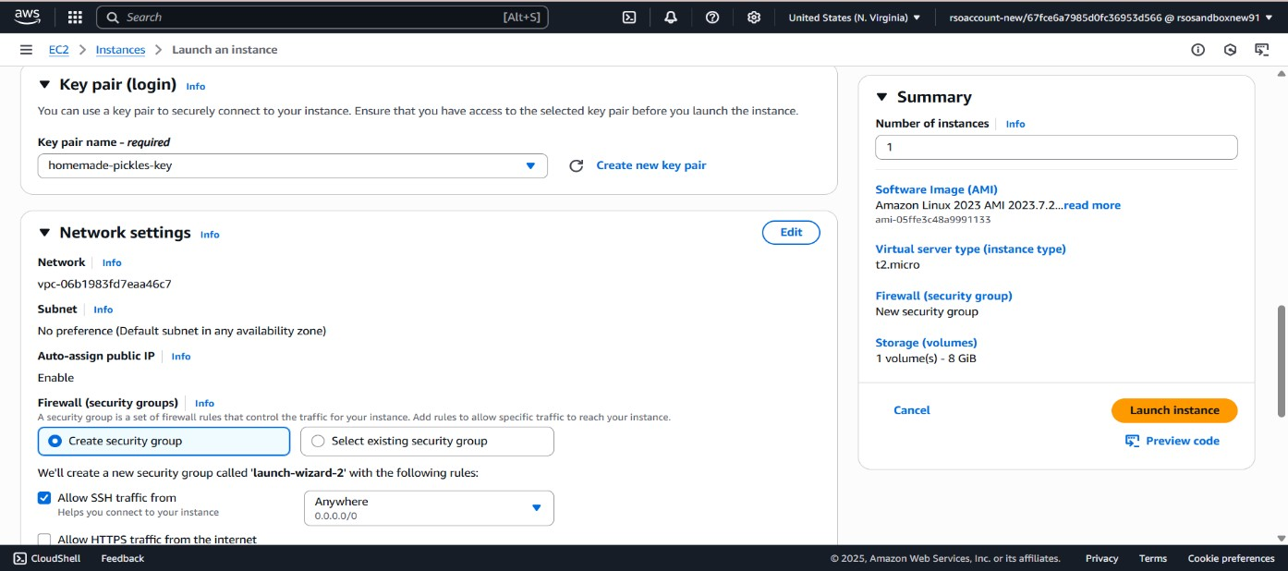

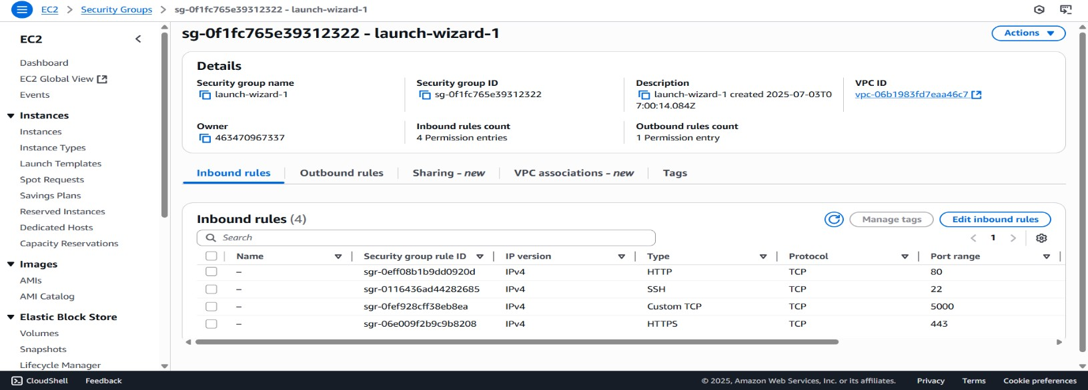

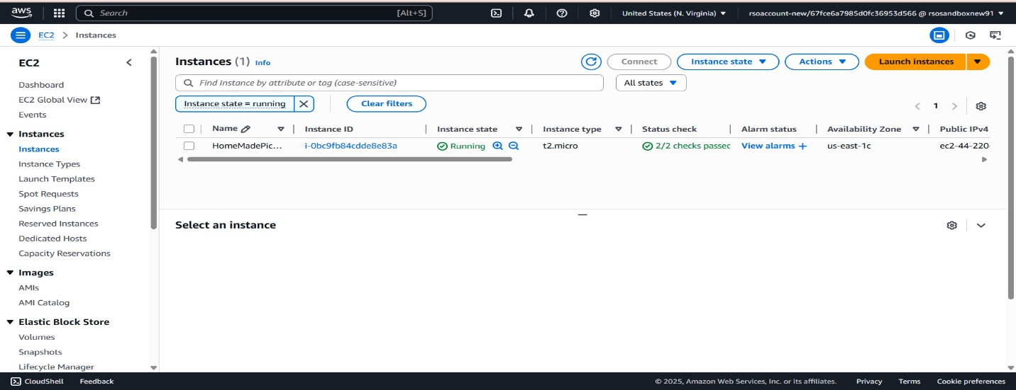

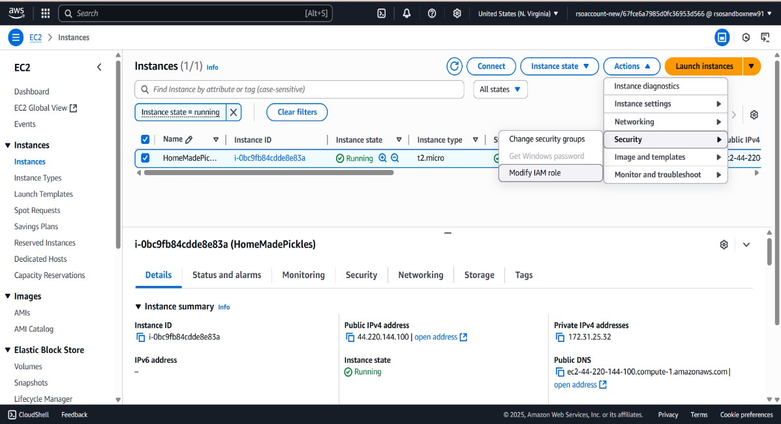

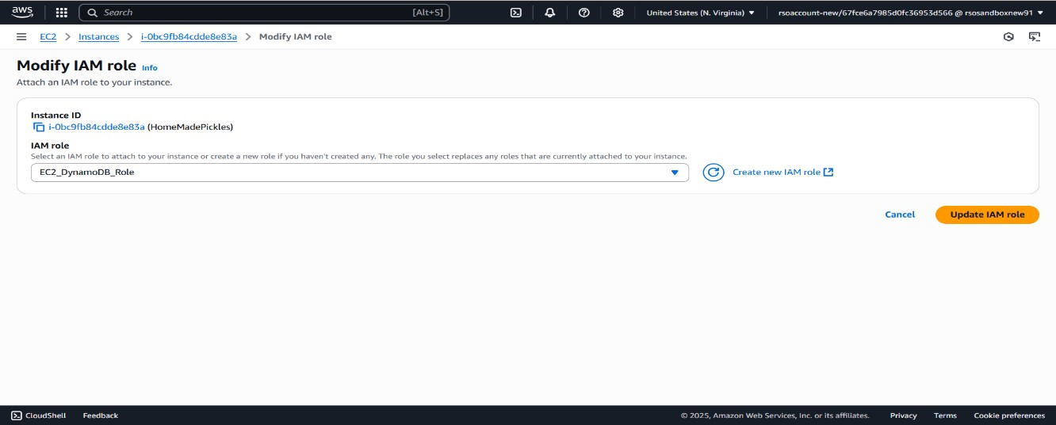

● 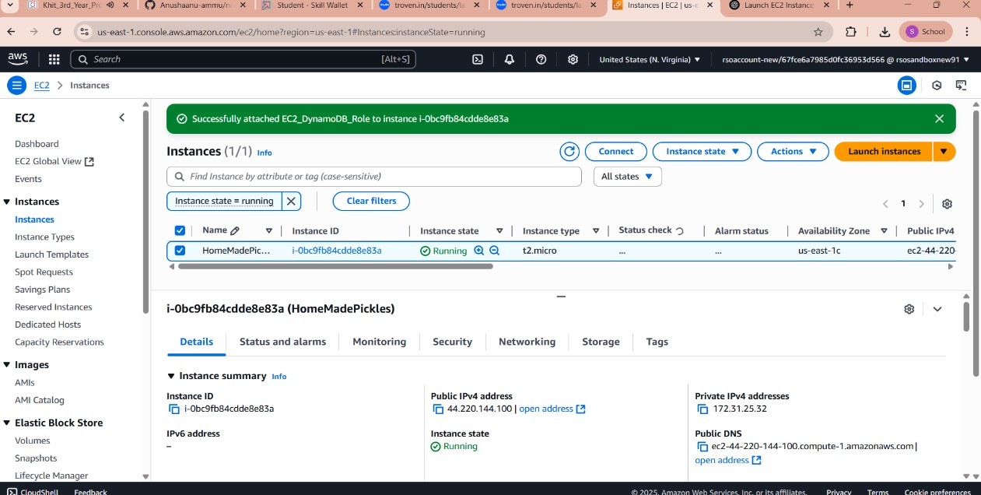

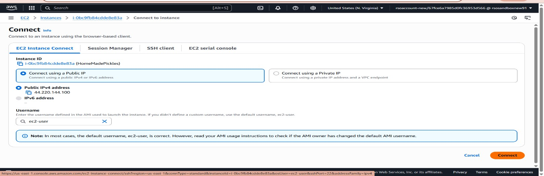

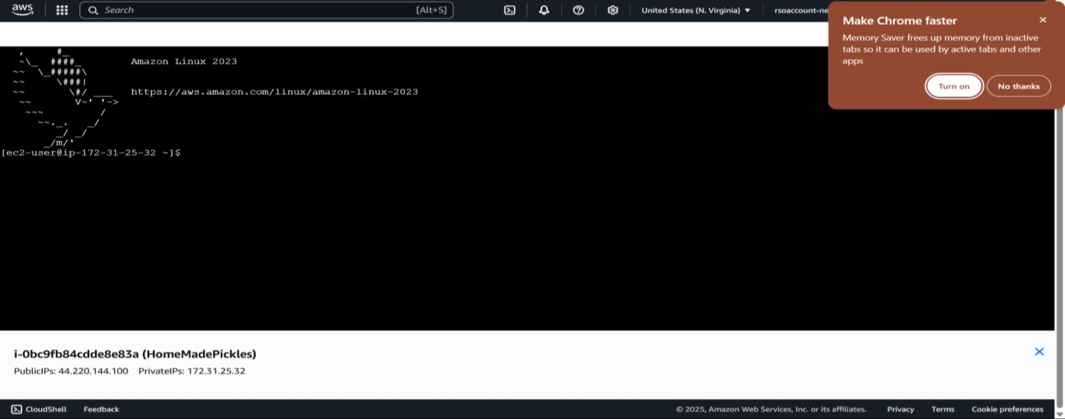

# Milestone 7: Deployment on EC2

**Activity 7.1: Install Software on the EC2 Instance**

* **Install Python3, Flask, and Git:**

* **On Amazon Linux 2:**
* **sudo yum update -y**
* **sudo yum install python3 git**
* **sudo pip3 install flask boto3**
* **Verify Installations:**
* **flask --version**
* **git –version**

**Activity 7.2 : Clone Your Flask Project from GitHub.**

**Clone your project repository from GitHub into the EC2 instance using Git.**

Run : ’ git clone [https://github.com/Pooja-Gajula/home-made.git](https://github.com/Pooja-Gajula/home-made.git%20) [’](https://github.com/Anushaanu-ammu/newUpdates-home).

This will download the Project to Ec2 instance .

**To navigate to the project directory, run the following command:**

**cd InstantLibrary**

**Once inside the project directory, configure and run the Flask application by executing the following command with elevated privileges:**

**Run the Flask Application**

sudo flask run --host=0.0.0.0 --port=80

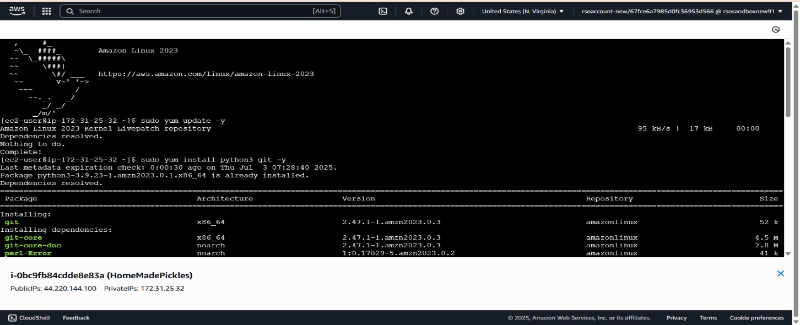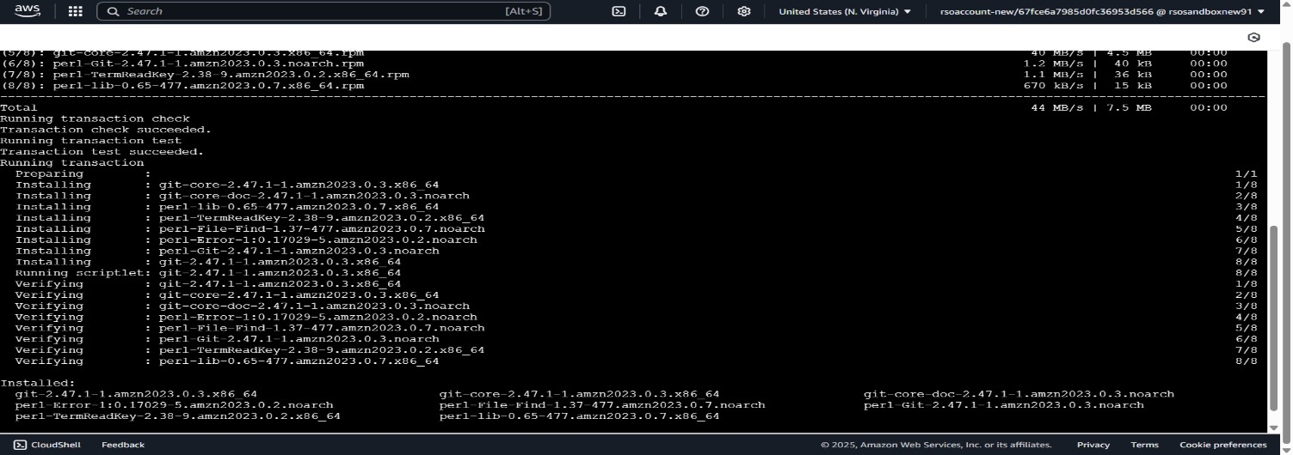

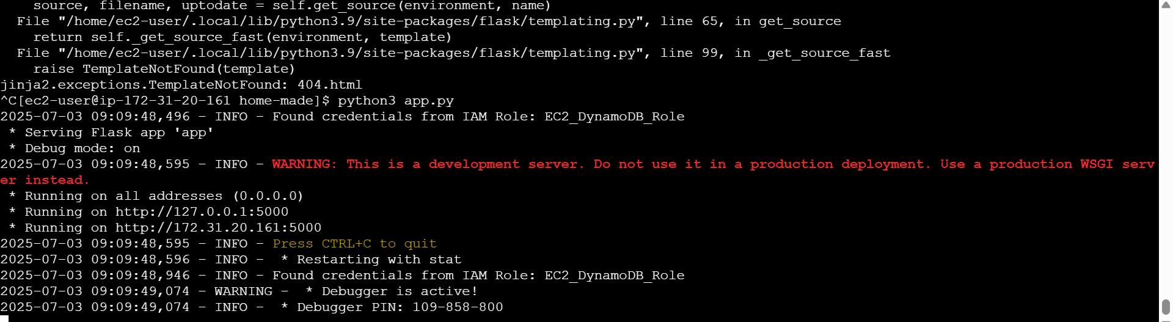

**Access the website through:**

**Public IPs:** http://3.95.226.32:5000/

# Milestone 8. Testing and Deployment

**Activity 8.1 :** Conduct functional testing to verify user signup, login, buy/sell stocks and notifications.

**HOME PAGE:**

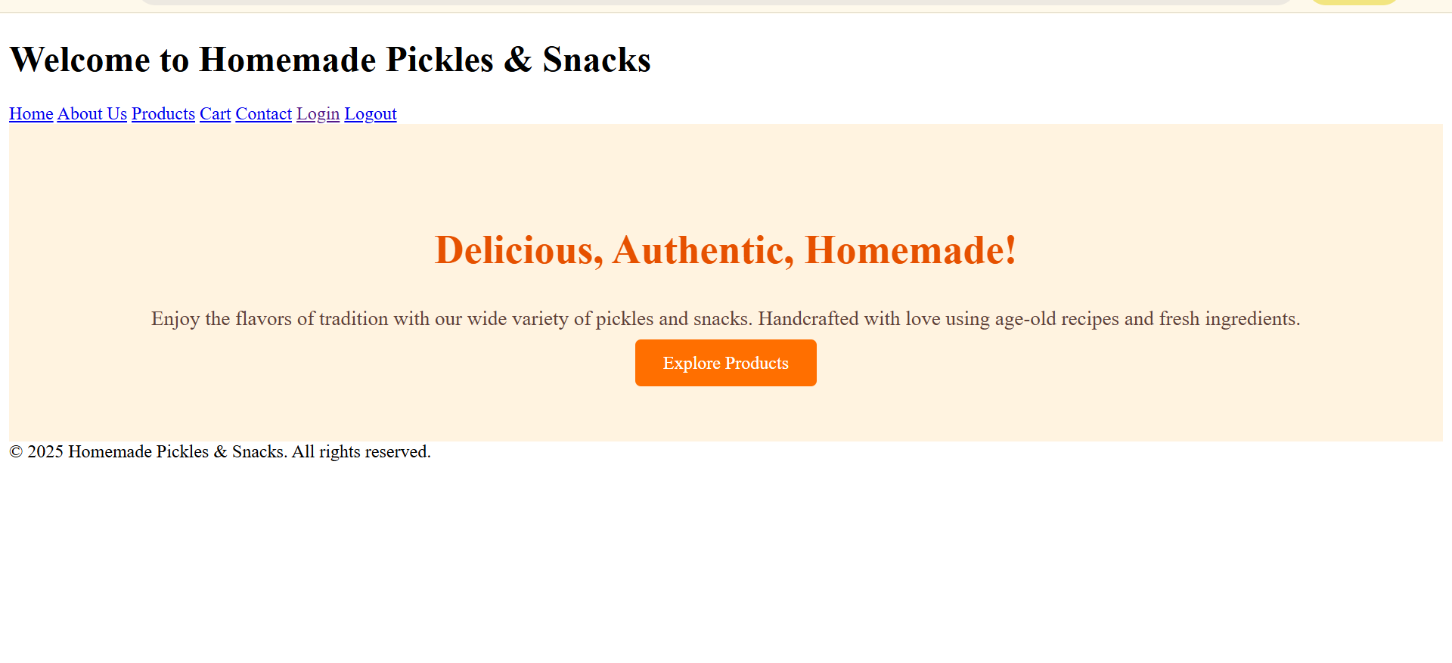

**LOGIN PAGE :**

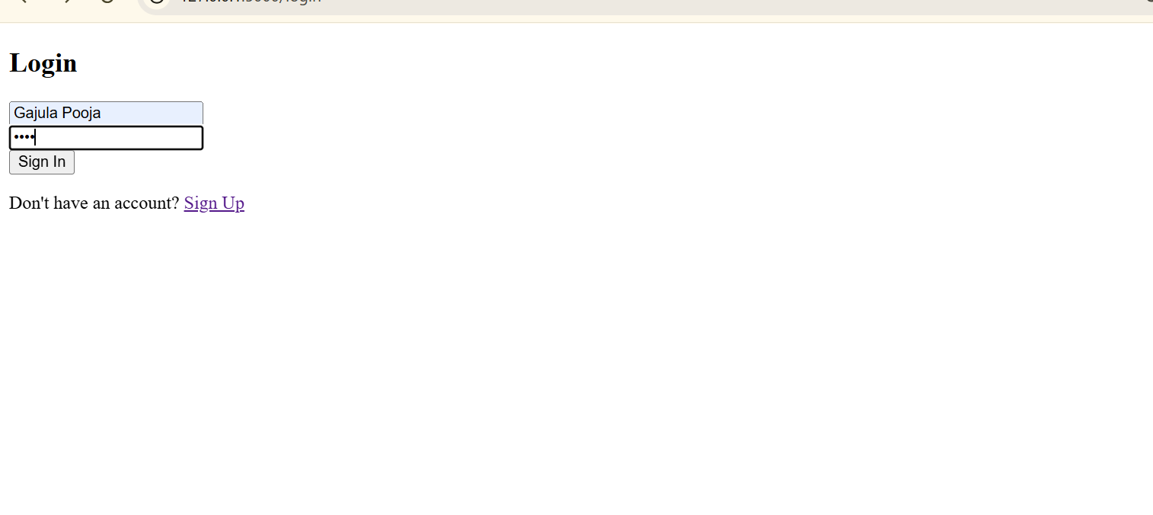

**SIGNUP PAGE :**

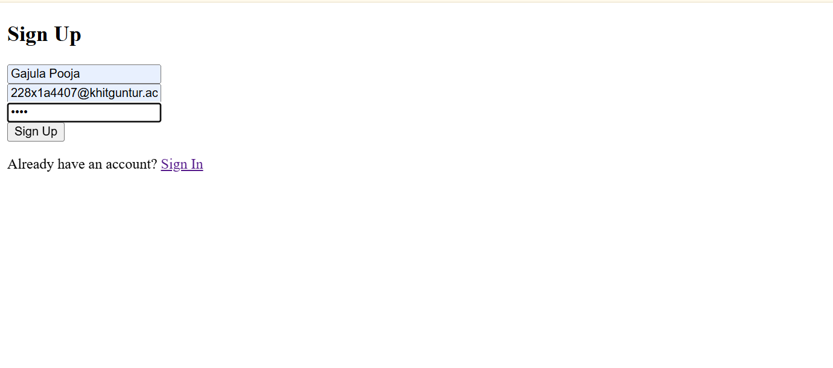 **VEG PAGE :**

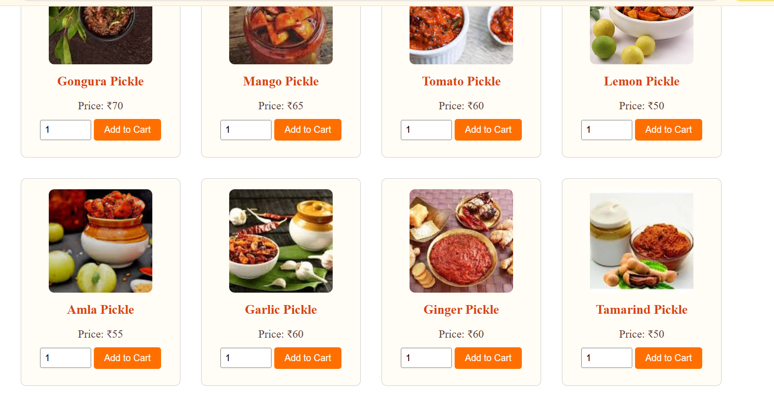

**NON VEG PAGE :**

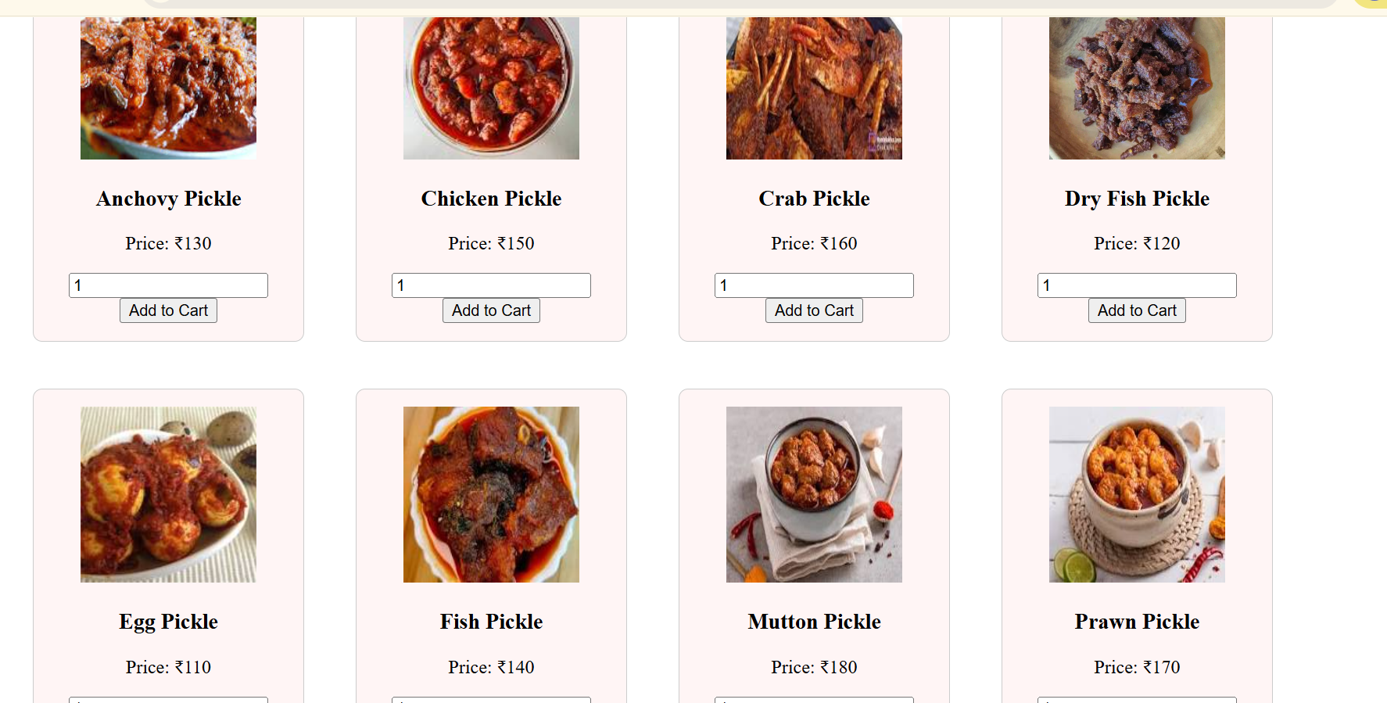

**SNACKS PAGE :**

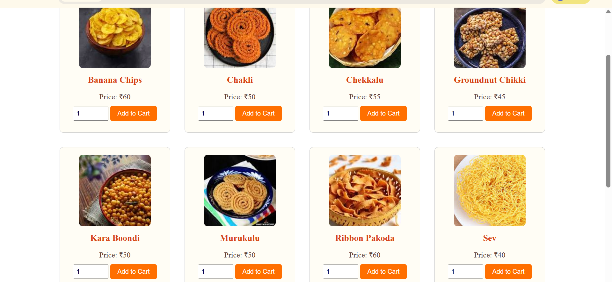

**CART PAGE :**

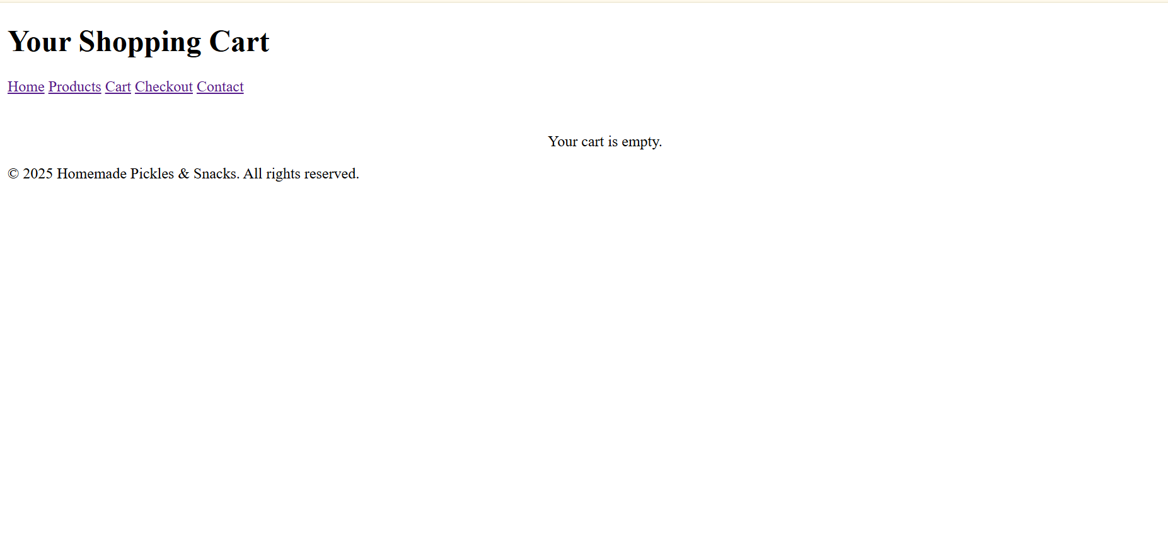

**CHECK OUT PAGE :**

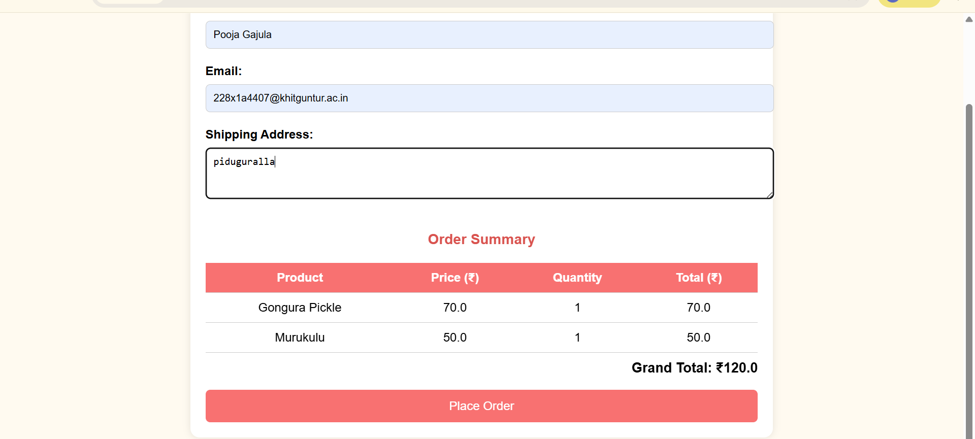

**SUCCESS PAGE :**

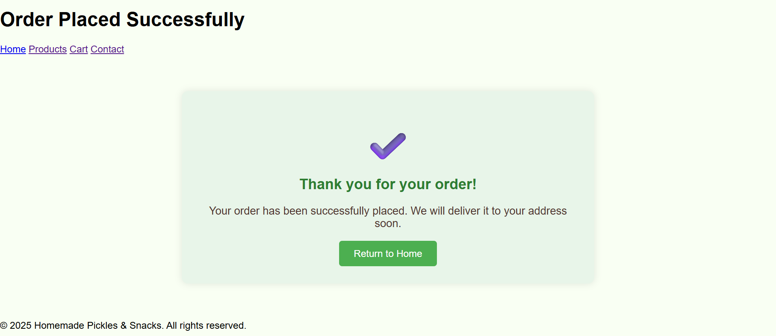

**ABOUT PAGE :**

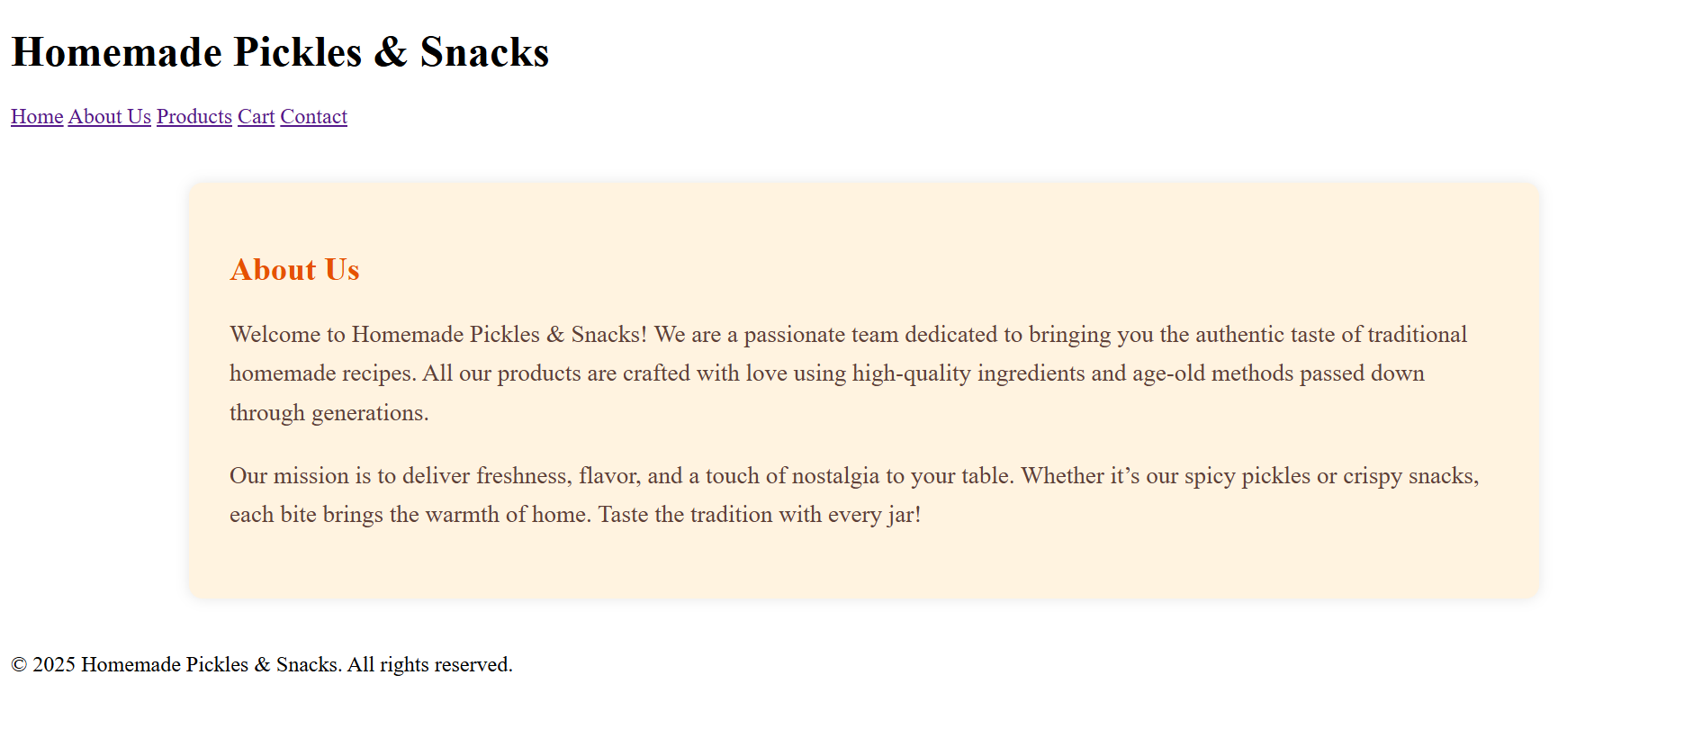

**CONTACT PAGE :**

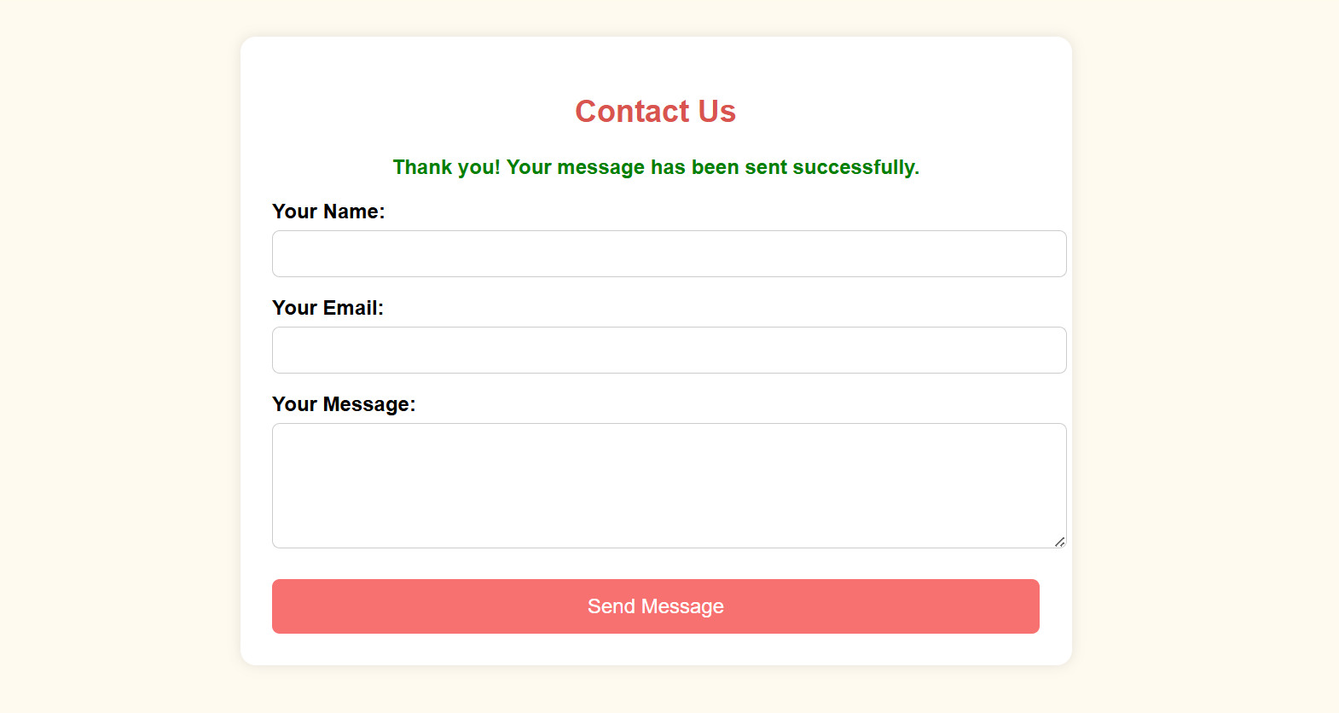

**Conclusion:**

Homemade pickles and snacks are more than just tasty treats—they represent a rich culinary tradition rooted in culture, care, and creativity. Unlike mass-produced options, homemade versions are crafted using natural, high-quality ingredients without preservatives or artificial additives. This ensures not only better taste and texture but also a healthier alternative for conscious consumers.

Pickles, whether spicy, tangy, or sweet, are a time-tested way of preserving seasonal vegetables and fruits, enhancing their flavours with a blend of spices, oils, and traditional techniques. Likewise, homemade snacks—ranging from roasted legumes and savoury mixtures to sweet bites—are made in small batches, allowing for personalized recipes and consistent quality.

By preparing these items at home or sourcing them from small-scale local producers, you support sustainable practices, reduce chemical intake, and enjoy the nostalgic, homemade touch that reminds many of family kitchens and regional flavours.

In essence, homemade pickles and snacks combine health, heritage, and happiness in every bite—making them an ideal choice for those who value authenticity, taste, and mindful eating

……………………………………………………..THE END………………………………………………